**Mindfulness Journal for Increasing the Connection to Spirit**

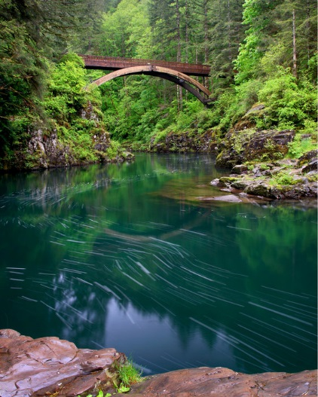

*Lower Lewis River Falls Gifford Pinchot National Forest, Cougar, WA*

We are all so busy with our lives running out of control with work, raising children, running businesses, social media, family demands! *take a breath*… We all need to give ourselves permission to STOP….to take a break and really come to understand what ‘smelling the roses’ means. We tend to lose our connection to the present moment and when that happens, we lose out on *feeling* what we are doing or noticing the pleasures and the *meaning* of what is right in front of us. Beginning a Mindfulness Practice was the turning point from living my life and trying to take care of others while I am in deficit to living my life to learning to nourish my spirit and being able to give to others from a place of abundance within myself.

Mindfulness has long been practiced around the globe as a means of focusing attention directly on the present moment and accepting our experiences just as they truly ARE without any of our judgements, expectations or filters; just noticing the here and now and ‘being’ in it. In recent years, research has been done that suggests that learning how to quiet the mind and be in the here and now is actually a crucial element to stress reduction and overall happiness.

Mindfulness can bring improvements in physical and psychological symptoms and positive changes in health, attitudes and behaviors. This is how it works: 1) purposefully *choose* what you will pay attention to, 2) practice holding your attention on that topic of focus for brief periods, 3) over time learning to focus for longer periods which there-by gives us the power to savor a pleasurable moment or feel and process emotions much more fully. Allowing ourselves to fully experience is essential to stopping what I call ‘mind chatter’.

Mindfulness can help improve sleep, relieve stress, improve blood pressure, reduce chronic pain, ease depression, conquer eating disorders, aid in conflicts with loved ones and ease anxiety disorders such as PTSD and obsessive-compulsive disorder. Mindfulness teaches acceptance of life experiences rather than reacting with avoidance. Mindfulness helps with gaining perspective on irrational, maladaptive, limiting self-defeating thoughts and beliefs.

See Appendix for the instructions on the exact step-by-step way to practice Mindfulness. While you do not need to actually ‘meditate’ while practicing Mindfulness, it is helpful because meditation teaches how to quiet the mind. Because Mindfulness and meditation go so well together, there is a meditation exercise along with each journal prompt. You can find instructions on basic meditation in the Appendix.



*Mindful moments bring*

*Hearts back in line with what’s real*

*Let your mind be free*

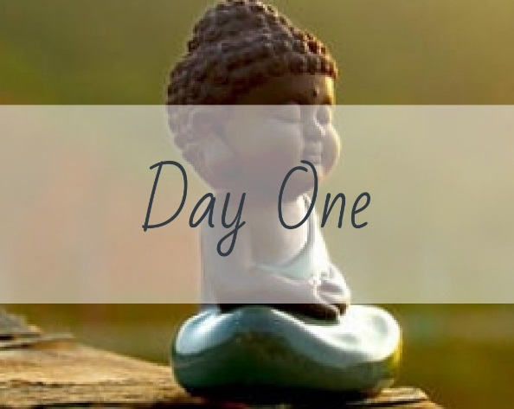

Find an object you find particularly beautiful. Look at it. Really examine it. What *IS* it that you find so beautiful? _______________________________________________ ______________________________________________________________________________________________________________________________________________________________________________________________________________________________________________________________________________________________________________________________________________________________________________________________________________________________________________________________________________________________________________________________________________________________________________________________________________________________________________________________________________________________________________________________________________________________________________________________________________________________________________________________________________________________________________________________________________________________________________________________________________________________________________________________________________________________________________________________________________________________________________________________________________________________________________________________________________________________________________________________________________________________________________________________________________________________________________________________________________________________________________________________________________________________________________

**Meditation**

As you examine your object bring your attention to its dimensions, colors, facets, shape, texture and the meaning it holds for you. Hold these observations in your minds as long as you can.

Describe the object: ____________________________________________________ _______________________________________________________________________________________________________________________________________________________________________________________________________________

Why does it hold so much meaning for you? _________________________________ _______________________________________________________________________________________________________________________________________________________________________________________________________________

What thoughts or memories does it bring up? _______________________________ _______________________________________________________________________________________________________________________________________________________________________________________________________________

Where in your body do you feel the object? _________________________________ _______________________________________________________________________________________________________________________________________________________________________________________________________________

Why do you feel the object there? _________________________________________ _______________________________________________________________________________________________________________________________________________________________________________________________________________

What emotions are connected to the object and why? ________________________ ______________________________________________________________________________________________________________________________________________________________________________________________________________________________________________________________________________________________________________________________________________________________________________________________________________________________

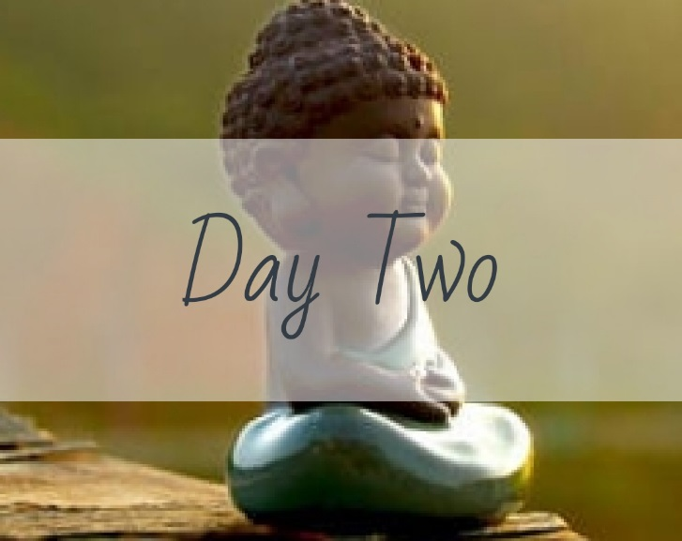

Where are you right NOW? Describe 5 things you see: ________________________ _______________________________________________________________________________________________________________________________________________________________________________________________________________

4 things you hear: ______________________________________________________ _______________________________________________________________________________________________________________________________________________________________________________________________________________

3 things you touch: _____________________________________________________ _______________________________________________________________________________________________________________________________________________________________________________________________________________

2 things you smell: _____________________________________________________

_______________________________________________________________________________________________________________________________________________________________________________________________________________

1 thing you taste: ______________________________________________________ _______________________________________________________________________________________________________________________________________________________________________________________________________________

**Meditation**

Think about what you experienced during the observation of Day Two.

Which sense seemed to be the ‘noisiest’, or the one in which you received the most information your environment? __________________________________________

____________________________________________________________________________________________________________________________________________________________________________________________________________________________________________________________________________________

What sort of information did you receive? Purely sensual or verbal as well? _______

____________________________________________________________________________________________________________________________________________________________________________________________________________________________________________________________________________________

Which sense seemed to be the ‘quietest’ or the most subtle? ___________________

_______________________________________________________________________________________________________________________________________________________________________________________________________________

Did you receive more information from the quiet sense, or less and why? _________

_______________________________________________________________________________________________________________________________________________________________________________________________________________

What was the overall message received – or thought that you held the longest during the exercise? __________________________________________________________

_______________________________________________________________________________________________________________________________________________________________________________________________________________

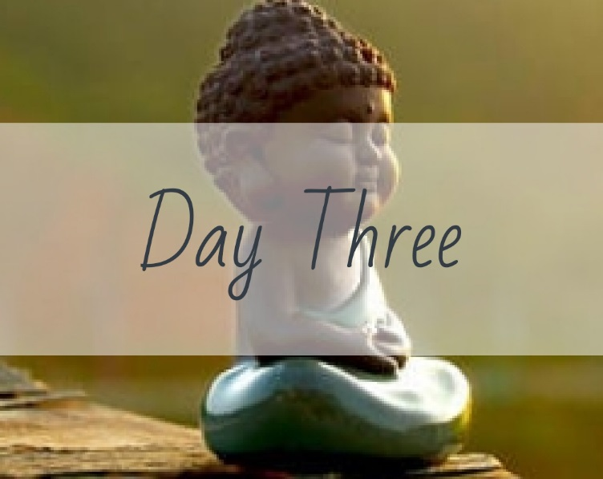

What does self-acceptance mean to you? ___________________________________ ______________________________________________________________________________________________________________________________________________________________________________________________________________________________________________________________________________________________________________________________________________________________________________________________________________________________________________________________________________________________________________________________________________________________________________________________________________________________________________________________________________________________________________________________________________________________________________________________________________________________________________________________________________________________________________________________________________________________________________________________________________________________________________________________________________________________________________________________________________________________________________________________________________________________________________________________________________________________________________________________________________________________________________________________________________________________________________________________________________________________________________________________________________________________________________

**Meditation**

What did you find difficult about this exercise? _______________________________ _______________________________________________________________________________________________________________________________________________________________________________________________________________

Why were these things difficult? __________________________________________ ____________________________________________________________________________________________________________________________________________________________________________________________________________________________________________________________________________________

What are the top three topics that you have a hard time accepting about yourself? ____________________________________________________________________________________________________________________________________________________________________________________________________________________________________________________________________________________

What beliefs do you have that keep you from accepting these 3 things? ___________

____________________________________________________________________________________________________________________________________________________________________________________________________________________________________________________________________________________

If these things were about a friend or loved one instead of yourself, and your loved one was having a hard time accepting these things about themselves, what would you tell them? _________________________________________________________ ______________________________________________________________________________________________________________________________________________________________________________________________________________________________________________________________________________________________________________________________________________________________________________________________________________________________

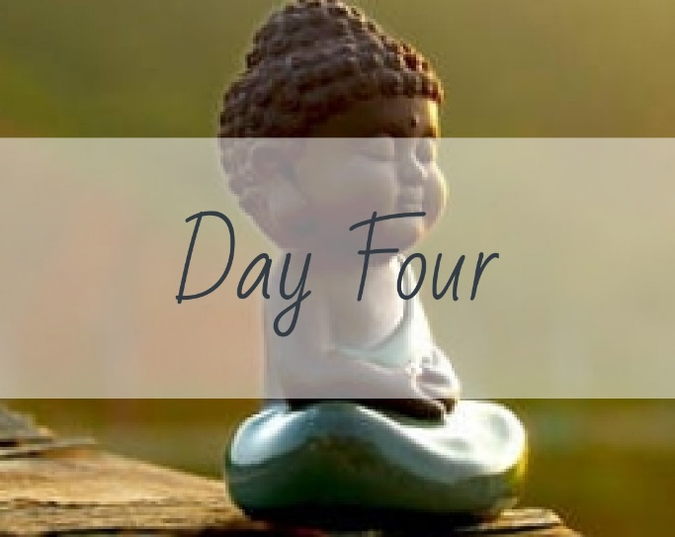

How do you feel emotionally in this moment? Give your full awareness to this emotion. Where is it in your body?________________________________________ ______________________________________________________________________________________________________________________________________________________________________________________________________________________________________________________________________________________________________________________________________________________________________________________________________________________________________________________________________________________________________________________________________________________________________________________________________________________________________________________________________________________________________________________________________________________________________________________________________________________________________________________________________________________________________________________________________________________________________________________________________________________________________________________________________________________________________________________________________________________________________________________________________________________________________________________________________________________________________________________________________________________________________________________________________________________________________________________________________________________________________________________________________________________________________________

**Meditation**

The emotion that you identified during the journal entry: How is the emotion impacting your life? ____________________________________________________ ____________________________________________________________________________________________________________________________________________________________________________________________________________________________________________________________________________________

In what ways does it cause you distress or unpleasant emotions? ________________ _________________________________________________________________________________________________________________________________________________________________________________________________________________________________________________________________________________________________________________________________________________________

Under what circumstances does this distress manifest (when/why does it rise to the surface usually)?_______________________________________________________ _________________________________________________________________________________________________________________________________________________________________________________________________________________________________________________________________________________________________________________________________________________________

Give it some deep pondering and then write down where you think the emotion stems from and 3 reasons you would like to learn to cope better with it: __________ _____________________________________________________________________________________________________________________________________________________________________________________________________________________________________________________________________________________________________________________________________________________________________________________________________________________________________________________________________________________________________________________________________________________________________________________________________________________________________________

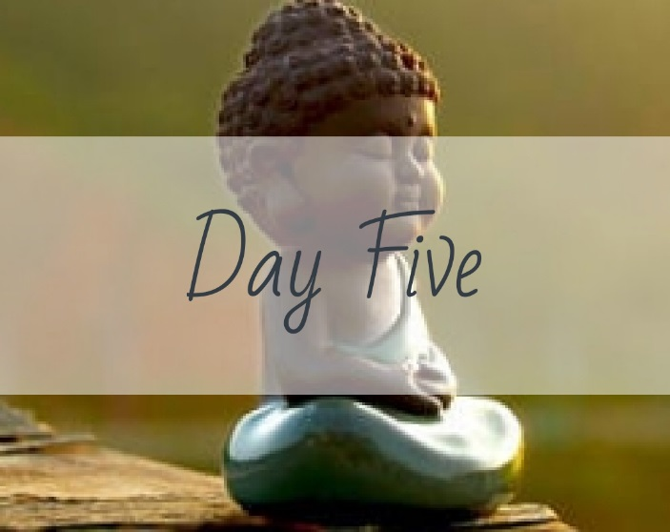

Name 3 things you could not live without and why?___________________________ ___________________________________________________________________________________________________________________________________________________________________________________________________________________________________________________________________________________________________________________________________________________________________________________________________________________________________________________________________________________________________________________________________________________________________________________________________________________________________________________________________________________________________________________________________________________________________________________________________________________________________________________________________________________________________________________________________________________________________________________________________________________________________________________________________________________________________________________________________________________________________________________________________________________________________________________________________________________________________________________________________________________________________________________________________________________________________________________________________________________________________________________________________________________________________________________________________________________________________________________

**Meditation**

Of the things you named above, which one is the most meaningful? Why? _________ _____________________________________________________________________________________________________________________________________________________________________________________________________________________________________________________________________________________________________________________________________________________________________________________________________________________________________________________________________________________________________________________________________________________________________________________________________________________________________________

Can you remember a time in your life when you did not have these things? How was your life different? _____________________________________________________ ____________________________________________________________________________________________________________________________________________________________________________________________________________________________________________________________________________________

How has having these 3 things contributed to your happiness?__________________ ___________________________________________________________________________________________________________________________________________________________________________________________________________________________________________________________________________________________________________________________________________________________________________________________________________________________________________________________________________________________________

How would you cope with their loss? _______________________________________ ______________________________________________________________________________________________________________________________________________________________________________________________________________________________________________________________________________________________________________________________________________________________________________________________________________________________

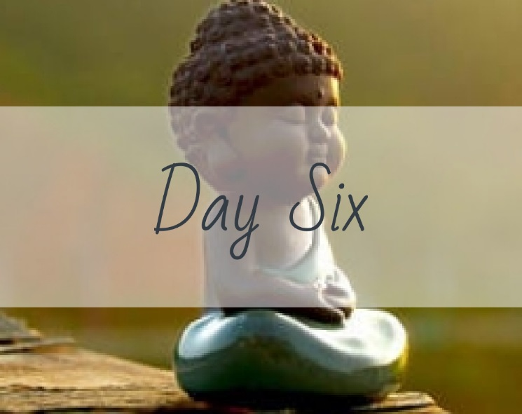

Write about your first love – whether it was a person, place or thing:_____________ ______________________________________________________________________________________________________________________________________________________________________________________________________________________________________________________________________________________________________________________________________________________________________________________________________________________________________________________________________________________________________________________________________________________________________________________________________________________________________________________________________________________________________________________________________________________________________________________________________________________________________________________________________________________________________________________________________________________________________________________________________________________________________________________________________________________________________________________________________________________________________________________________________________________________________________________________________________________________________________________________________________________________________________________________________________________________________________________________________________________________________________________________________________________________________________

**Meditation**

When you recall your first love, what feelings come up?________________________ _______________________________________________________________________________________________________________________________________________________________________________________________________________

At the time that you fell in love, what did this person/place/thing mean or represent to you? _______________________________________________________________ _______________________________________________________________________________________________________________________________________________________________________________________________________________

How do you currently fill those needs? _____________________________________ ____________________________________________________________________________________________________________________________________________________________________________________________________________________________________________________________________________________

Knowing what you know *now*, if you could go back in time, would you still choose that person/place/thing? Why or why not? __________________________________ ____________________________________________________________________________________________________________________________________________________________________________________________________________________________________________________________________________________

Would you choose that person/place/thing today? Why or why not? _____________ ____________________________________________________________________________________________________________________________________________________________________________________________________________________________________________________________________________________

What did you do for yourself that allowed you to heal from the loss of this person/place/thing? ____________________________________________________ ____________________________________________________________________________________________________________________________________________________________________________________________________________________________________________________________________________________

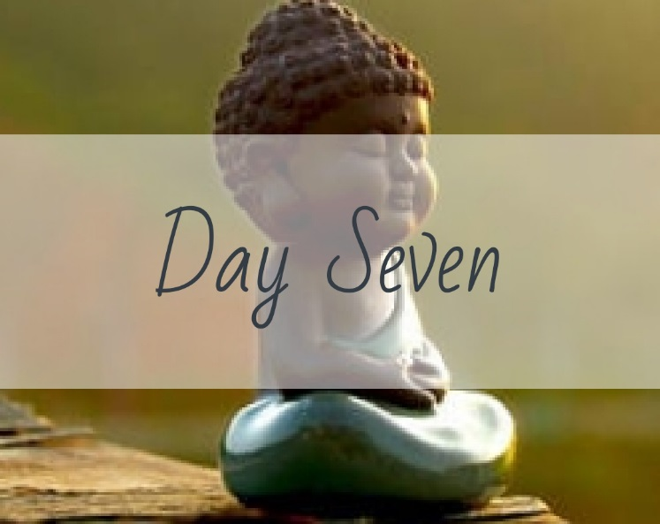

Unconditional love is love that continues even when the other person has done something horrible. You may not *like* what they have done and you may not *agree* with what they have done but you do not remove your love from them.

Do you agree with this statement? Why or why not? What does unconditional love look like to you?_______________________________________________________ __________________________________________________________________________________________________________________________________________________________________________________________________________________________________________________________________________________________________________________________________________________________________________________________________________________________________________________________________________________________________________________________________________________________________________________________________________________________________________________________________________________________________________________________________________________________________________________________________________________________________________________________________________________________________________________________________________________________________________________________________________________________________________________________________________________________________________________________________________________________________________________________________________________________________________________________________________________________

**Meditation**

Unconditional love is so essential, at least in childhood, for a person to feel safe and to be able to take chances and grow into who they are meant to be.

Do you feel as though you received unconditional love as you were growing up? In what ways do you believe the presence or lack of unconditional love affected your development? _________________________________________________________ ______________________________________________________________________________________________________________________________________________________________________________________________________________________________________________________________________________________________________________________________________________________________________________________________________________________________

How might you have been different if you had or had not received unconditional love? ________________________________________________________________ ___________________________________________________________________________________________________________________________________________________________________________________________________________________________________________________________________________________________________________________________________________________________________________________________________________________________________________________________________________________________________

Are you currently capable of giving unconditional love and to whom? Why or why not? _________________________________________________________________ ________________________________________________________________________________________________________________________________________________________________________________________________________________________________________________________________________________________________________________________________________________________________________________________________________________________________________________________________________________________________________________________________________________________________________

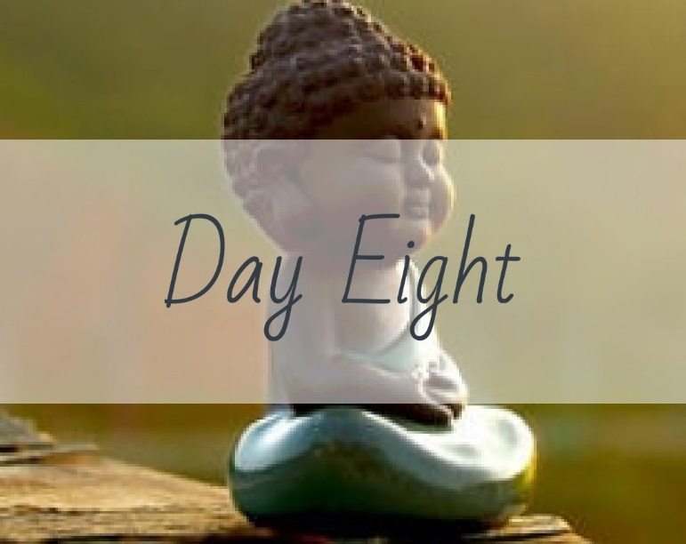

What always brings tears to your eyes?_____________________________________ ______________________________________________________________________________________________________________________________________________________________________________________________________________________________________________________________________________________________________________________________________________________________________________________________________________________________________________________________________________________________________________________________________________________________________________________________________________________________________________________________________________________________________________________________________________________________________________________________________________________________________________________________________________________________________________________________________________________________________________________________________________________________________________________________________________________________________________________________________________________________________________________________________________________________________________________________________________________________________________________________________________________________________________________________________________________________________________________________________________________________________________________________________________________________________________

**Meditation**

*Grab the “Ride the Wave” Exercise from the Appendix for this meditation.*

Write a bit about why this identified thing above always brings tears to your eyes: What is your personal connection to it that makes it so powerful? _______________

___________________________________________________________________________________________________________________________________________________________________________________________________________________________________________________________________________________________________________________________________________________________________________________________________________________________________________________________________________________________________

When you are being affected, what are your thoughts around this emotionally powerful stimuli? ______________________________________________________ ______________________________________________________________________________________________________________________________________________________________________________________________________________________________________________________________________________________________________________________________________________________________________________________________________________________________

Sit with these emotions for a few minutes and allow yourself to really feel them. Where do you feel these emotions? _______________________________________ ____________________________________________________________________________________________________________________________________________________________________________________________________________________________________________________________________________________

Using the “Ride the Wave” Skill, think about feeling the height of the sensation and then, slowly, the emotion easing up. Discuss your experience of that: ____________ _______________________________________________________________________________________________________________________________________________________________________________________________________________ __________________________________________________________________________________________________________________________________________

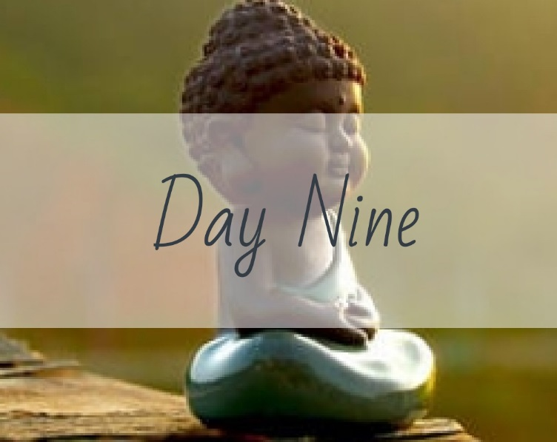

Discuss what is “enough” for you in your life: ________________________________ ______________________________________________________________________________________________________________________________________________________________________________________________________________________________________________________________________________________________________________________________________________________________________________________________________________________________________________________________________________________________________________________________________________________________________________________________________________________________________________________________________________________________________________________________________________________________________________________________________________________________________________________________________________________________________________________________________________________________________________________________________________________________________________________________________________________________________________________________________________________________________________________________________________________________________________________________________________________________________________________________________________________________________________________________________________________________________________________________________________________________________________________________________________________________________________

**Meditation**

In your above work, what were 3 ‘take-aways’ from what you believe is ‘enough’ for you? _________________________________________________________________ ______________________________________________________________________________________________________________________________________________________________________________________________________________________________________________________________________________________________________________________________________________________________________________________________________________________________

Did you find that what you believe to be enough is something achievable or something you constantly chase and why? __________________________________ ______________________________________________________________________________________________________________________________________________________________________________________________________________________________________________________________________________________________________________________________________________________________________________________________________________________________

What do you think of the idea of gratitude? _________________________________ _______________________________________________________________________________________________________________________________________________________________________________________________________________ _____________________________________________________________________

In reference to the list of things that you believe you have ‘enough’ of in your life, list out 3 things you are grateful for about each one: _____________________________ ___________________________________________________________________________________________________________________________________________________________________________________________________________________________________________________________________________________________________________________________________________________________________________________________________________________________________________________________________________________________________

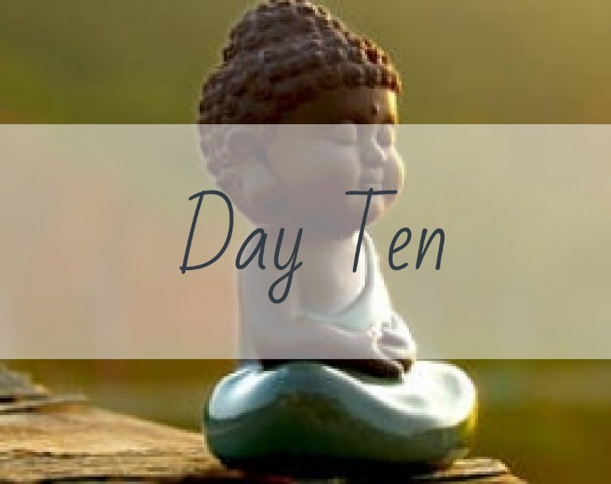

Write about a time when you felt complete joy, happiness or ‘oneness’ with everything around you:__________________________________________________ _________________________________________________________________________________________________________________________________________________________________________________________________________________________________________________________________________________________________________________________________________________________________________________________________________________________________________________________________________________________________________________________________________________________________________________________________________________________________________________________________________________________________________________________________________________________________________________________________________________________________________________________________________________________________________________________________________________________________________________________________________________________________________________________________________________________________________________________________________________________________________________________________________________________________________________________________________________________________________________________________________________________________________________________________________________________________________________________________________________________________________

**Meditation**

When you were experiencing the all-consuming joy or ‘oneness’, where did you feel it in your body?________________________________________________________ __________________________________________________________________________________________________________________________________________

Describe the feeling: ____________________________________________________ ______________________________________________________________________________________________________________________________________________________________________________________________________________________________________________________________________________________________________________________________________________________________________________________________________________________________

Some people liken this feeling to being in touch with the entire universe at once, of all being right with the world and absent of all fear and worry. Make a list of 3 other activities you have in your life right now that give you the same feeling: ___________

______________________________________________________________________________________________________________________________________________________________________________________________________________________________________________________________________________________________________________________________________________________________________________________________________________________________

Discuss the barriers that keep you from experiencing a ‘spiritual orgasm’ as often as you can: ______________________________________________________________ _____________________________________________________________________________________________________________________________________________________________________________________________________________________________________________________________________________________________________________________________________________________________________________________________________________________________________________________________________________________________________________________________________________________________________________________________________________________________________________

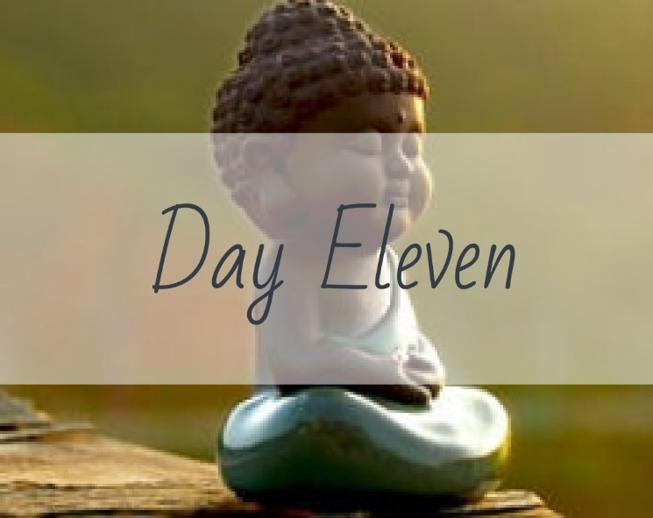

Write the words you need to hear: ________________________________________ ________________________________________________________________________________________________________________________________________________________________________________________________________________________________________________________________________________________________________________________________________________________________________________________________________________________________________________________________________________________________________________________________________________________________________________________________________________________________________________________________________________________________________________________________________________________________________________________________________________________________________________________________________________________________________________________________________________________________________________________________________________________________________________________________________________________________________________________________________________________________________________________________________________________________________________________________________________________________________________________________________________________________________________________________________________________________________________________________________________________________________________________________________________________________________________________________________________________________________________________________________________________________________________________

**Meditation**

Read over your writing of “the words you want to hear”. Write down any patterns you see in what you want to hear. Are they love words, appreciation words, gratitude words? _______________________________________________________ _______________________________________________________________________________________________________________________________________________________________________________________________________________

How do you imagine you would feel if you heard these words? __________________ ____________________________________________________________________________________________________________________________________________________________________________________________________________________________________________________________________________________

How would your life be different if you heard these words? ____________________ _________________________________________________________________________________________________________________________________________________________________________________________________________________________________________________________________________________________________________________________________________________________

What are the barriers that keep you from hearing those words? _________________ ____________________________________________________________________________________________________________________________________________________________________________________________________________________________________________________________________________________________________________________________________________________________________________________________________________________________________________________________________________________________________________________________________________________________________________________________________________________________________________________________________________________________________________________________________________________________________________________________________________________________________________________________

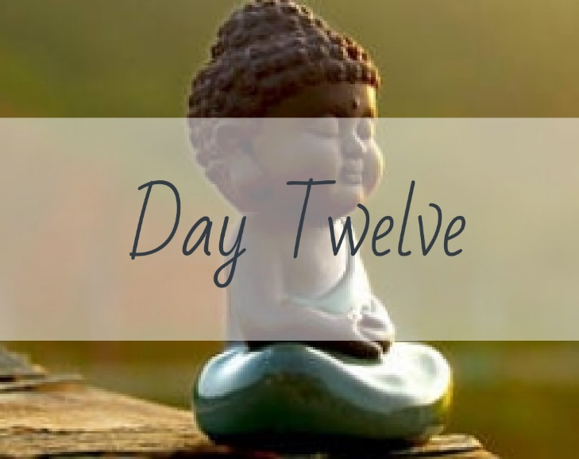

What makes you feel alive? ______________________________________________ _________________________________________________________________________________________________________________________________________________________________________________________________________________________________________________________________________________________________________________________________________________________

The most needed? _____________________________________________________ _________________________________________________________________________________________________________________________________________________________________________________________________________________________________________________________________________________________________________________________________________________________

The most engaged? _____________________________________________________ _________________________________________________________________________________________________________________________________________________________________________________________________________________________________________________________________________________________________________________________________________________________

The most fulfilled? _____________________________________________________ _________________________________________________________________________________________________________________________________________________________________________________________________________________________________________________________________________________________________________________________________________________________

**Meditation**

In what ways do the answers to the four questions overlap? ____________________ ______________________________________________________________________________________________________________________________________________________________________________________________________________________________________________________________________________________________________________________________________________________________________________________________________________________________

If you have yourself coming back to a few pain points, or points that need to change throughout this journal, what are they? ____________________________________ _________________________________________________________________________________________________________________________________________________________________________________________________________________________________________________________________________________________________________________________________________________________

What is your plan to begin making changes in your life in regard to these pain points? ___________________________________________________________________________________________________________________________________________________________________________________________________________________________________________________________________________________________________________________________________________________________________________________________________________________________________________________________________________________________________

What might you need help with in your journey to change? _____________________ ________________________________________________________________________________________________________________________________________________________________________________________________________________________________________________________________________________________________________________________________________________________________________________________________________________________________________________________________________________________________________________________________________________________________________

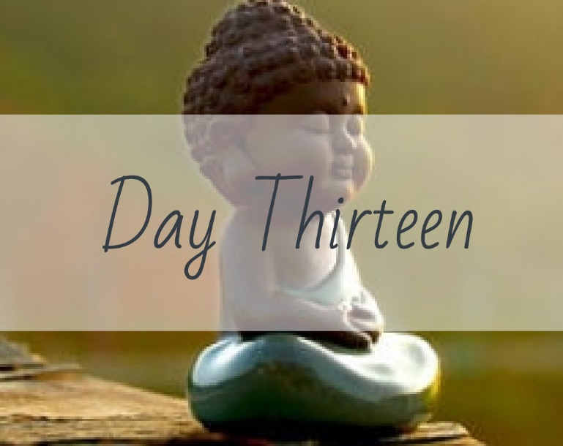

What things would you like to say ‘no’ to in your life? _________________________ ______________________________________________________________________________________________________________________________________________________________________________________________________________________________________________________________________________________________________________________________________________________________________________________________________________________________________________________________________________________________________________________________________________________________________________________________________________________________________________________________________________________________________________________________________________________________________________________________________________________________________________________________________________________________________________________________________________________________________________________________________________________________________________________________________________________________________________________________________________________________________________________________________________________________________________________________________________________________________________________________________________________________________________________________________________________________________________________________________________________________________________________________________________________________________________

**Meditation**

Saying ‘no’ is a very powerful expression of self. Often we are taught that saying no is not polite, however, I argue that NOT saying no puts us in a state of being disingenuous which automatically throws us out of alignment with spirit.

What are your barriers to saying no? A desire not to disappoint or come across as rude? An unwillingness to be ‘selfish’ and put your needs first? __________________ ______________________________________________________________________________________________________________________________________________________________________________________________________________________________________________________________________________________________________________________________________________________________________________________________________________________________

In what ways do these barriers serve you? __________________________________ _________________________________________________________________________________________________________________________________________________________________________________________________________________________________________________________________________________________________________________________________________________________

How do the barriers limit you? ____________________________________________ ____________________________________________________________________________________________________________________________________________________________________________________________________________________________________________________________________________________

If the barriers limit your own growth, why do you allow them to rule your responses?

______________________________________________________________________________________________________________________________________________________________________________________________________________________________________________________________________________________________________________________________________________________________________________________________________________________________

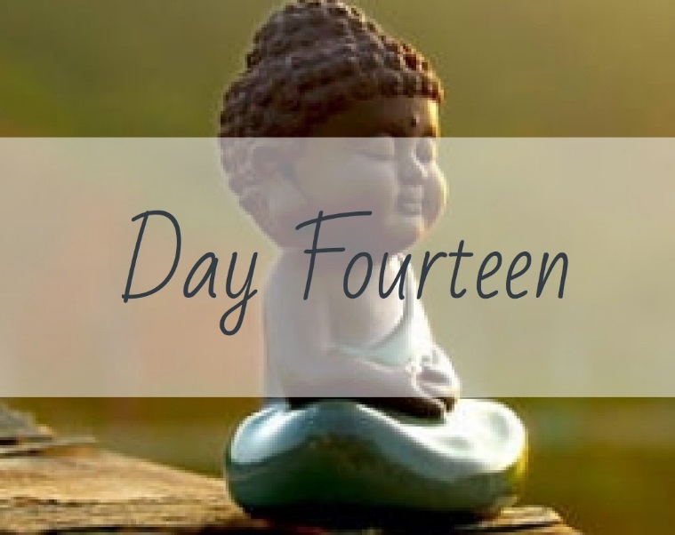

What activities, self-care or people refuel you emotionally that you could integrate into your life on a regular basis?__________________________________________ _________________________________________________________________________________________________________________________________________________________________________________________________________________________________________________________________________________________________________________________________________________________________________________________________________________________________________________________________________________________________________________________________________________________________________________________________________________________________________________________________________________________________________________________________________________________________________________________________________________________________________________________________________________________________________________________________________________________________________________________________________________________________________________________________________________________________________________________________________________________________________________________________________________________________________________________________________________________________________________________________________________________________________________________________________________________________________________________________________________________________________

**Meditation**

Consider the ways in which you can integrate more of what and/or who you love into your life: _____________________________________________________________ ___________________________________________________________________________________________________________________________________________________________________________________________________________________________________________________________________________________________________________________________________________________________________________________________________________________________________________________________________________________________________

How will your life be different when you incorporate these things? _______________ _____________________________________________________________________________________________________________________________________________________________________________________________________________________________________________________________________________________________________________________________________________________________________________________________________________________________________________________________________________________________________________________________________________________________________________________________________________________________________________

In what ways will incorporating these things into your life raise your spiritual vibration and contribute to your happiness? _________________________________ _______________________________________________________________________________________________________________________________________________________________________________________________________________________________________________________________________________________________________________________________________________________________________________________________________________________________________________________________________________________________________________________________________________________________________________________________________________________________________________________________________________________________________________________________________________________________________________________

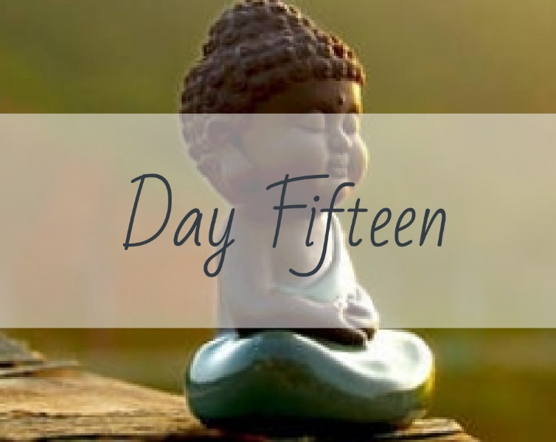

Describe three masks you wear in different compartments of your life: ___________ ______________________________________________________________________________________________________________________________________________________________________________________________________________________________________________________________________________________________________________________________________________________________________________________________________________________________

What are the strengths and limitations of each of the masks?___________________ ___________________________________________________________________________________________________________________________________________________________________________________________________________________________________________________________________________________________________________________________________________________________________________________________________________________________________________________________________________________________________

How did you get stuck in these various roles? ________________________________ ______________________________________________________________________________________________________________________________________________________________________________________________________________________________________________________________________________________________________________________________________________________________________________________________________________________________

**Meditation**

Sit for a moment and contemplate removing the masks. What would happen if you decided to take off the masks? ____________________________________________ ____________________________________________________________________________________________________________________________________________________________________________________________________________________________________________________________________________________

What are your barriers to taking off the masks? ______________________________ ______________________________________________________________________________________________________________________________________________________________________________________________________________________________________________________________________________________________________________________________________________________________________________________________________________________________

How would you feel if you were finally FREE of all the charades and pretenses? _____ ___________________________________________________________________________________________________________________________________________________________________________________________________________________________________________________________________________________________________________________________________________________________________________________________________________________________________________________________________________________________________

List 3 ways you could start wiggling off one of the masks: ______________________ ________________________________________________________________________________________________________________________________________________________________________________________________________________________________________________________________________________________________________________________________________________________________________________________________________________________________________________________________________________________________________________________________________________________________________

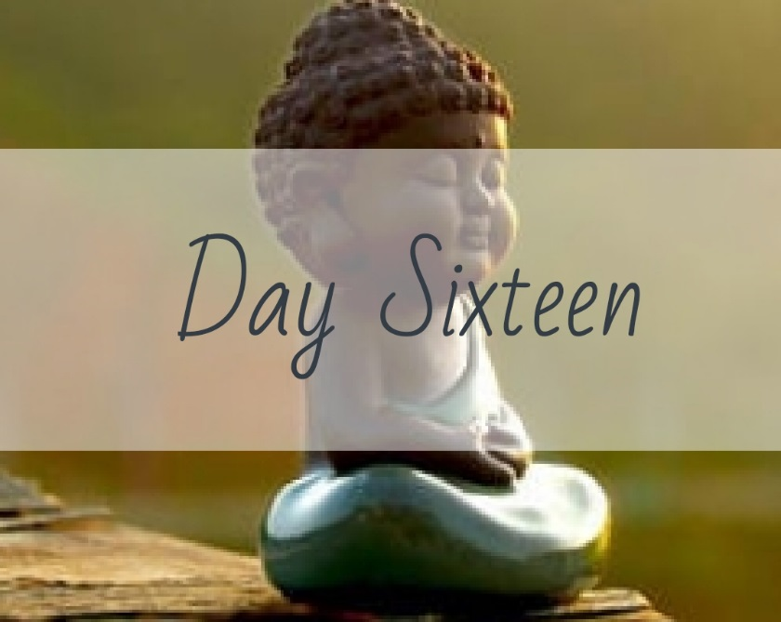

How do you over-perform in your life? _____________________________________ ____________________________________________________________________________________________________________________________________________________________________________________________________________________________________________________________________________________________________________________________________________________________________________________________________________________________________________________________________________________________________________________________________________________________________________________________________________________________________________________________________________________________________________________________________________________________________________________________________________________________________________________________________________________________________________________________________________________________________________________________________________________________________________________________________________________________________________________________________________________________________________________________________________________________________________________________________________________________________________________________________________________________________________________________________________________________________

**Meditation**

Do you remember when the over-performance began in your life? If you can remember approximately when it started, describe the circumstances: ___________ ______________________________________________________________________________________________________________________________________________________________________________________________________________________________________________________________________________________________________________________________________________________________________________________________________________________________

How did the over-performance make you feel? What did you get out of it? ________

___________________________________________________________________________________________________________________________________________________________________________________________________________________________________________________________________________________________________________________________________________________________________________________________________________________________________________________________________________________________________

Describe the ways in which you over-perform in your adult life:__________________ ______________________________________________________________________________________________________________________________________________________________________________________________________________________________________________________________________________________________________________________________________________________________________________________________________________________________

As an adult, does over-performing bring reward? What do you get out of it now?

___________________________________________________________________________________________________________________________________________________________________________________________________________________________________________________________________________________________________________________________________________________________________________________________________________________________________________________________________________________________________

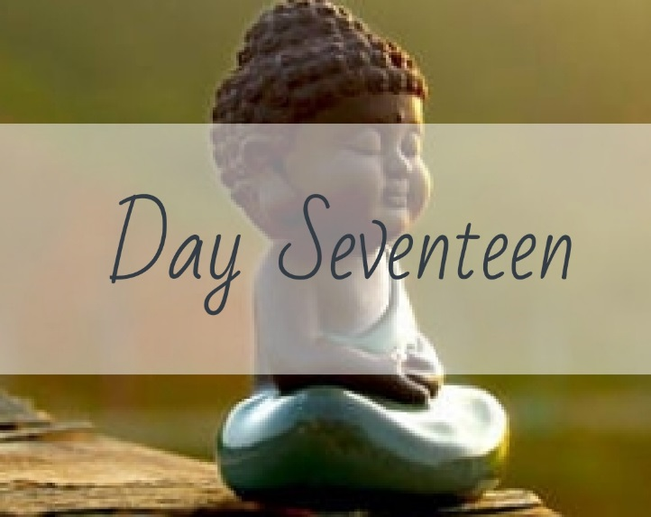

What or whose ideals are you trying to live up to?_____________________________

________________________________________________________________________________________________________________________________________________________________________________________________________________________________________________________________________________________________________________________________________________________________________________________________________________________________________________________________________________________________________________________________________________________________________________________________________________________________________________________________________________________________________________________________________________________________________________________________________________________________________________________________________________________________________________________________________________________________________________________________________________________________________________________________________________________________________________________________________________________________________________________________________________________________________________________________________________________________________________________________________________________________________________________________________________________________________________________________________________________________________________________________________________________________________________________________________________________________________________________________________________________________________________________

**Meditation**

Are you being served by the ideals you are trying to live up to? List out 5 ways they are helping you be the best person you can be: ______________________________ ____________________________________________________________________________________________________________________________________________________________________________________________________________________________________________________________________________________ _____________________________________________________________________

Discuss your level of comfort or discomfort with these ideals: ___________________ ____________________________________________________________________________________________________________________________________________________________________________________________________________________________________________________________________________________ _____________________________________________________________________

Do you have ideals of your own that you live by? List out 5 of your own ideals: _____ _________________________________________________________________________________________________________________________________________________________________________________________________________________________________________________________________________________________________________________________________________________________

If you were to scrap old ideals, or replace them, which ones would they be? _______ ____________________________________________________________________________________________________________________________________________________________________________________________________________________________________________________________________________________ _____________________________________________________________________

What would happen if you did?____________________________________________ _________________________________________________________________________________________________________________________________________________________________________________________________________________________________________________________________________________________________________________________________________________________

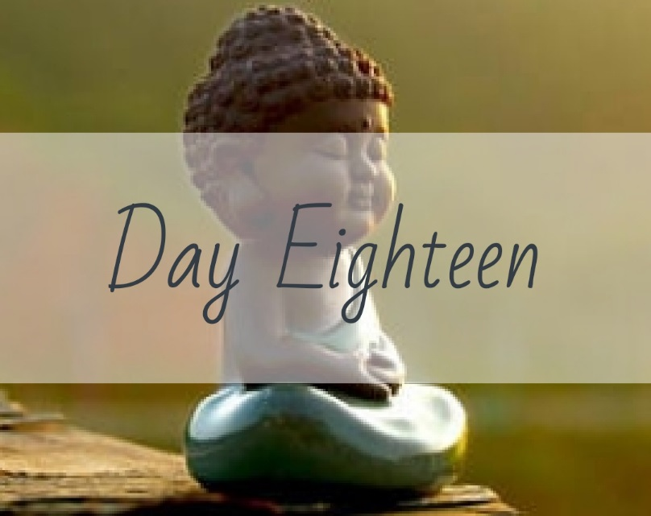

If you were free of the need to perform to prove yourself, how would you like to spend your time?_______________________________________________________ ____________________________________________________________________________________________________________________________________________________________________________________________________________________________________________________________________________________________________________________________________________________________________________________________________________________________________________________________________________________________________________________________________________________________________________________________________________________________________________________________________________________________________________________________________________________________________________________________________________________________________________________________________________________________________________________________________________________________________________________________________________________________________________________________________________________________________________________________________________________________________________________________________________________________________________________________________________________________________________________________________________________________________________________________________________________________________ __________________________________________________________________________________________________________________________________________

**Meditation**

Think of how freeing it would be to spend your time anyway you wanted! Describe how your life would be different: __________________________________________ _________________________________________________________________________________________________________________________________________________________________________________________________________________________________________________________________________________________________________________________________________________________

How would living your dream FEEL? ________________________________________   
____________________________________________________________________________________________________________________________________________________________________________________________________________________________________________________________________________________

How would it affect your loved ones? ______________________________________ ____________________________________________________________________________________________________________________________________________________________________________________________________________________________________________________________________________________

What are your barriers to living in this way? _________________________________ ______________________________________________________________________________________________________________________________________________________________________________________________________________________________________________________________________________________________________________________________________________________________________________________________________________________________

Name 3 ways in which you could start removing the obstacles: __________________ ______________________________________________________________________________________________________________________________________________________________________________________________________________________________________________________________________________________________________________________________________________________________________________________________________________________________

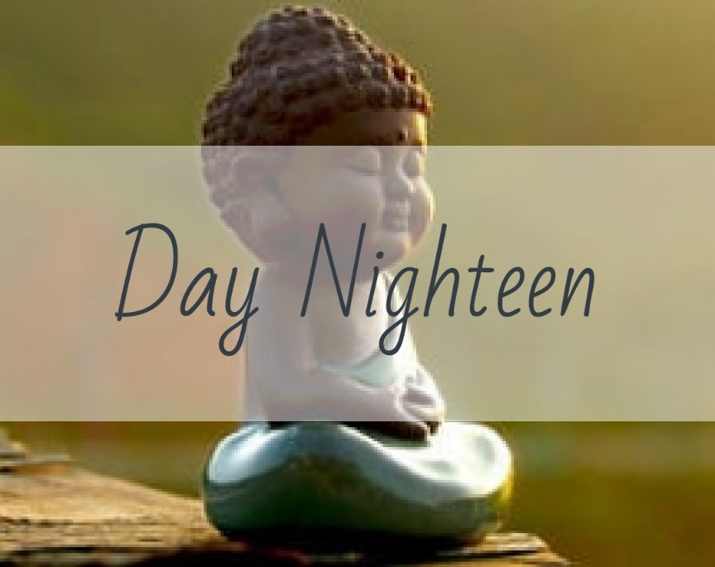

What are you enthusiastic about in your life?________________________________ ______________________________________________________________________________________________________________________________________________________________________________________________________________________________________________________________________________________________________________________________________________________________________________________________________________________________________________________________________________________________________________________________________________________________________________________________________________________________________________________________________________________________________________________________________________________________________________________________________________________________________________________________________________________________________________________________________________________________________________________________________________________________________________________________________________________________________________________________________________________________________________________________________________________________________________________________________________________________________________________________________________________________________________________________________________________________________________________________________________________________________________________________________________________________________________

**Meditation**

Interestingly, the question above can be a very heavy topic for some people. Take the “Basic Meditation Instructions” and the “Ride the Wave” exercise out of the Appendix and use it here. Record some of your thoughts that ran through your mind as you were spending time giving yourself the space to process.

____________________________________________________________________________________________________________________________________________________________________________________________________________________________________________________________________________________________________________________________________________________________________________________________________________________________________________________________________________________________________________________________________________________________________________________________________________________________________________________________________________________________________________________________________________________________________________________________________________________________________________________________________________________________________________________________________________________________________________________________________________________________________________________________________________________________________________________________________________________________________________________________________________________________________________________________________________________________________________________________________________________________________________________________________________________________________________________________________________________________________________________________________________________________________________________________________________________________________________________________________________________________________________________________________________________________________________________________________________________________________________________________________________________________________________________________________________________________________________________________________________

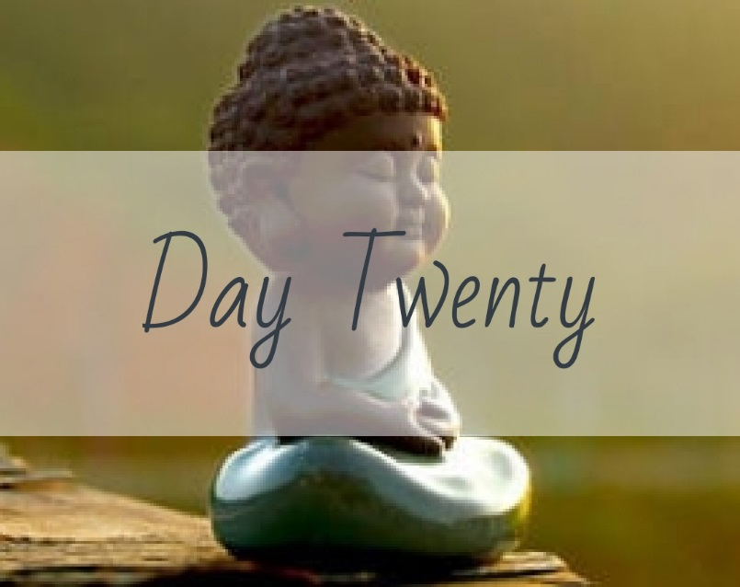

Write down a list of 5 things that you can think about that takes you completely out of a stressful situation: __________________________________________________ ________________________________________________________________________________________________________________________________________________________________________________________________________________________________________________________________________________________________________________________________________________________________________________________________________________________________________________________________________________________________________________________________________________________________________

What do these thoughts connect you to that is powerful enough to break the stress of the situation? Why do they work? _______________________________________ _____________________________________________________________________ __________________________________________________________________________________________________________________________________________________________________________________________________________________________________________________________________________________________________________________________________________________________________________________________________________________________________________________________________________________________________________________________________________________________________________________________________________________________________________________________________________________________________________________

**Meditation**

The 5 things that you listed above are instant ‘mindful subjects’ for you. You can pull them out of your back pocket and use them any time you want. Discuss a time in the recent past where you were able to calm and focus yourself with these thoughts: ___ ___________________________________________________________________________________________________________________________________________________________________________________________________________________________________________________________________________________________________________________________________________________________________________________________________________________________________________________________________________________________________

Come up with 5 more that, with some practice, you could use for alternate topics (hint – some of the topics may be something that we have already talked about!): _________________________________________________________________________________________________________________________________________________________________________________________________________________________________________________________________________________________________________________________________________________________ __________________________________________________________________________________________________________________________________________

Think about other times in your every day life where you could use a ‘mindfulness moment’. Maybe its during a meeting you hate, or maybe it is a way that you calm yourself before talking to a particular client, customer or your boss. When could YOU use the mindful moment?________________________________________________ _________________________________________________________________________________________________________________________________________________________________________________________________________________________________________________________________________________________________________________________________________________________ ____________________________________________________________________________________________________________________________________________________________________________________________________________________________________________________________________________________

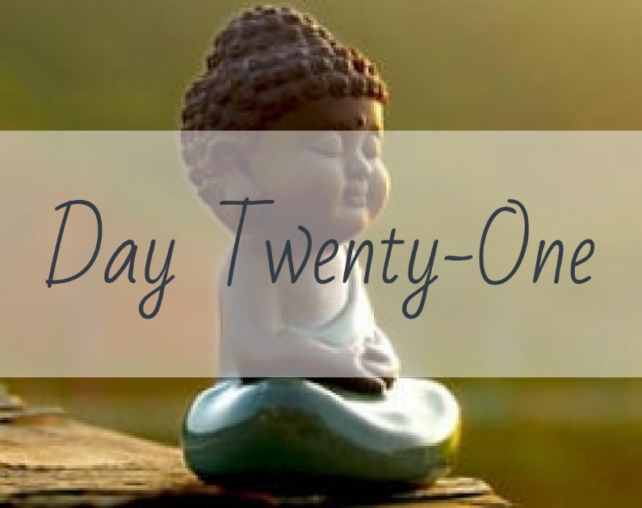

Choose one of the things from the list you made yesterday and think about that thing right now. _______________________________________________________ __________________________________________________________________________________________________________________________________________________________________________________________________________________________________________________________________________________________________________________________________________________________________________________________________________________________________________________________________________________________________________________________________________________________________________________________________________________________________________________________________________________________________________________

Journal how your energy shifted: __________________________________________ __________________________________________________________________________________________________________________________________________________________________________________________________________________________________________________________________________________________________________________________________________________________________________________________________________________________________________________________________________________________________________________________________________________________________________________________________________________________________________________________________________________________________________________

**Meditation**

Think about the journaling you did yesterday. You had an energy shift when you spent the few minutes thinking about your stress relieving topic. Discuss your feelings prior to taking the mindful moment, the thoughts that you had while taking the break for the mindful moment and then how you felt after the mindful moment:

____________________________________________________________________________________________________________________________________________________________________________________________________________________________________________________________________________________________________________________________________________________________________________________________________________________________________________________________________________________________________________________________________________________________________________________________________________________________________________________________________________________________________________________________________________________________________________________________________________________________________________________________________________________________________________________________________________________________________________________________________________________________________________________________________________________________________________________________________________________________________________________________________________________________________________________________________________________________________________________________________________________________________________________________________________________________________________________________________________________________________________________________________________________________________________________________________________________________________________________________________________________________________________________________________________________________________________________________________________________________________________________________________________________________________________________________________________________________________________________________________________



What is calling to your spirit? _____________________________________________ __________________________________________________________________________________________________________________________________________________________________________________________________________________________________________________________________________________________________________________________________________________________________________________________________________________________________________________________________________________________________________________________________________________________________________________________________________________________________________________________________________________________________________________

How will you answer? ___________________________________________________ _____________________________________________________________________________________________________________________________________________________________________________________________________________________________________________________________________________________________________________________________________________________________________________________________________________________________________________________________________________________________________________________________________________________________________________________________________________________________________________

**Meditation**

Maybe you have heard your spirit calling you for a long time. Maybe you have dreamed about the spirit call for a long time, planning it out…but you haven’t taken any action. Think deeply and honestly about what stands in your way and then journal about your reasons, your WHY that keeps you thinking about your spirit call: ____________________________________________________________________________________________________________________________________________________________________________________________________________________________________________________________________________________________________________________________________________________________________________________________________________________________________________________________________________________________________________________________________________________________________________________________________________________________________________________________________________________________________________________________________________________________________________________________________________________________________________________________ ____________________________________________________________________________________________________________________________________________________________________________________________________________________________________________________________________________________________________________________________________________________________________________________________________________________________________________________________________________________________________________________________________________________________________________________________________________________________________________________________________________________________________________________________________________________________________________________________________________________________________________________________

____________________________________________________________________________________________________________________________________________________________________________________________________________________________________________________________________________________

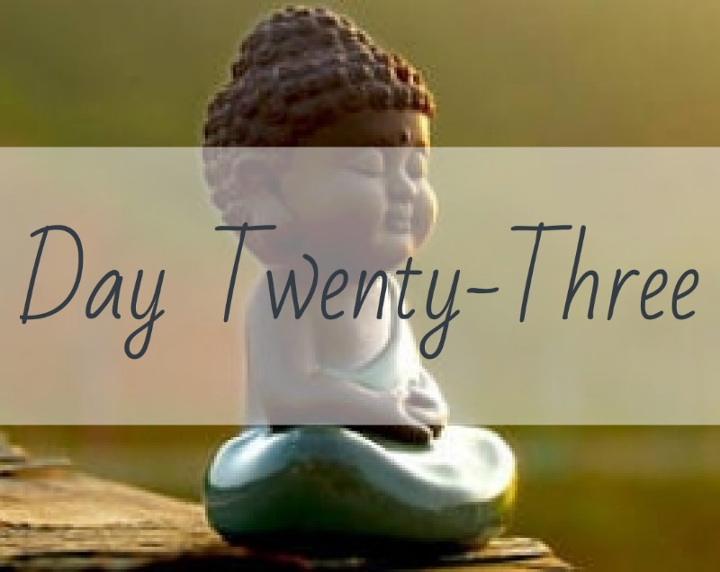

What are you inviting into your life with your actions? _________________________ ________________________________________________________________________________________________________________________________________________________________________________________________________________________________________________________________________________________________________________________________________________________________________________________________________________________________________________________________________________________________________________________________________________________________________

What will happen if you don’t listen to your spirit? ____________________________ _________________________________________________________________________________________________________________________________________________________________________________________________________________________________________________________________________________________________________________________________________________________

What is your plan to align your actions with your desired path? _________________ ___________________________________________________________________________________________________________________________________________________________________________________________________________________________________________________________________________________________________________________________________________________________________________________________________________________________________________________________________________________________________

**Meditation**

Check your level of awareness:

1. What ARE the actions you are taking in your life? _______________________ ________________________________________________________________________________________________________________________________________________________________________________________________________________________________________________________________________________________________________________________________________________________________________________________________________________________________________________________________
2. What IS your spirit trying to communicate? If you don’t know or can’t hear it, take some time to figure that out. “Spirit talk” often shows up as a ‘pain point’, something you have that is nagging at you to start or complete. ________________________________________________________________________________________________________________________________________________________________________________________________________________________________________________________________________________________________________________________________________________________________________________________________________________________________________________________________
3. Name 3 things that seem like they could be your ‘next available steps’ in your life: Ex. If you just finished college, your next three steps might be to get a job, save up a little money, get your own place. ____________________________ ________________________________________________________________________________________________________________________________________________________________________________________________________________________________________________________________________________________________________________________________________________________________________________________________________________________________________________________________________________________________________________________________

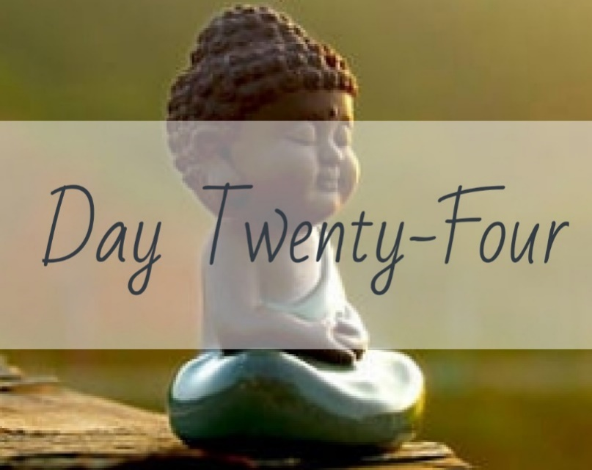

Think back to a time you agreed to do something that was a “*Hell YEAH I want to do this!”* type of event for you. What was it? ___________________________________ ______________________________________________________________________________________________________________________________________________________________________________________________________________________________________________________________________________________________________________________________________________________________________________________________________________________________

Maybe it was difficult or inconvenient, but you were thrilled to do it anyways. How did that feel? __________________________________________________________ _________________________________________________________________________________________________________________________________________________________________________________________________________________________________________________________________________________________________________________________________________________________

In what way (s) did this event align with your path or journey? __________________ ___________________________________________________________________________________________________________________________________________________________________________________________________________________________________________________________________________________________________________________________________________________________________________________________________________________________________________________________________________________________________

**Meditation**

Doing something that really aligns with your spirit and path usually feels *really* good, and it should because it ‘plays to your wheelhouse’. Consider how that energy feels. Spend some time meditating on the feeling. Describe how the ‘replay’ of this memory continues to make you feel: _______________________________________ ________________________________________________________________________________________________________________________________________________________________________________________________________________________________________________________________________________________________________________________________________________________________________________________________________________________________________________________________________________________________________________________________________________________________________

How does the memory contribute to your happiness? _________________________ _____________________________________________________________________________________________________________________________________________________________________________________________________________________________________________________________________________________________________________________________________________________________________________________________________________________________________________________________________________________________________________________________________________________________________________________________________________________________________________

Describe any other emotions that come up: _________________________________ _____________________________________________________________________________________________________________________________________________________________________________________________________________________________________________________________________________________________________________________________________________________________________________________________________________________________________________________________________________________________________________________________________________________________________________________________________________________________________________

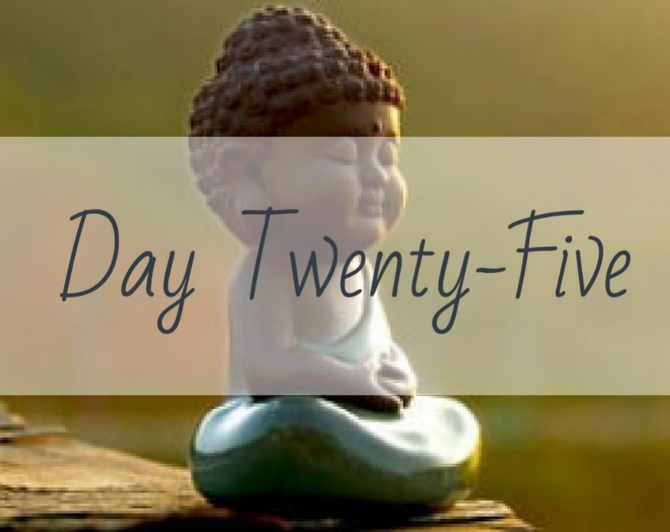

Describe a time you’ve agreed to do something that is not a “hell yeah” only “I guess I should.” _____________________________________________________________ _______________________________________________________________________________________________________________________________________________________________________________________________________________

How does your body feel when you’re saying yes? ____________________________ _______________________________________________________________________________________________________________________________________________________________________________________________________________ _____________________________________________________________________

What thoughts makes you say yes?  ________________________________________ ____________________________________________________________________________________________________________________________________________________________________________________________________________________________________________________________________________________

Where is your energy when you’re doing the task? ____________________________ ____________________________________________________________________________________________________________________________________________________________________________________________________________________________________________________________________________________ _____________________________________________________________________

**Meditation**

Think about a time when you did something you felt saying ‘no’ was not an option. Using your reflections above, spend some time on these next questions:

What kept you moving through the activity when you didn’t want to participate? ___ ___________________________________________________________________________________________________________________________________________________________________________________________________________________________________________________________________________________________________________________________________________________________________________________________________________________________________________________________________________________________________

How did you feel about the task after your participation was completed? _________ ______________________________________________________________________________________________________________________________________________________________________________________________________________________________________________________________________________________________________________________________________________________________________________________________________________________________

Not that we should ever feel forced, but sometimes when we ‘do it anyway’ we are better for it. Try to think of some things you have done that you thought you did not want to do but in doing it ended up with a blessing or a lesson learned: ___________

_______________________________________________________________________________________________________________________________________________________________________________________________________________________________________________________________________________________________________________________________________________________________________________________________________________________________________________________________________________________________________________________________________________________________________________________________________________________________________________________________________________________________________________________________________________________________________________________

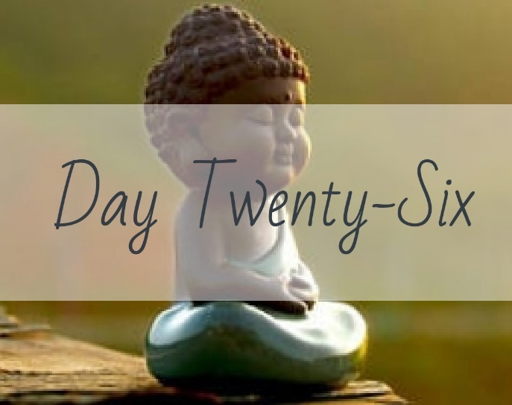

Try it: Stay with an unpleasant feeling or emotion, for 30 seconds or so – next time you’re irritated, upset or fearful. Simply “be present” with that emotion, don’t judge it, just feel for a moment – what is that experience like? _______________________ ____________________________________________________________________________________________________________________________________________________________________________________________________________________________________________________________________________________

Scale of 1-10, how hard is it to stay with that feeling? _________________________ _______________________________________________________________________________________________________________________________________________________________________________________________________________

Does focusing on your breath help you sit with feelings of anger or fear? Why or why not? _________________________________________________________________ __________________________________________________________________________________________________________________________________________

When do you most need to “just breathe?”__________________________________

What keeps you from pausing – notice and write about your thoughts. ___________

______________________________________________________________________________________________________________________________________________________________________________________________________________________________________________________________________________________________________________________________________________________________________________________________________________________________

**Meditation**

Sitting with unpleasant feelings takes practice and so does learning to take time for ourselves and breathe through those emotions. Recall the last incident in your life where you had an opportunity to practice: __________________________________ __________________________________________________________________________________________________________________________________________________________________________________________________________________________________________________________________________________________________________________________________________________________________________________________________________________________________________________________________________________________________________________________________________________________________________________________________________________________________________________________________________________________________________________

In the Appendix you will find the ‘Ride the Wave’ technique instructions. Think about this last incident where you had to sit with unpleasant feelings and try applying the ‘Ride the Wave’ technique for a few minutes. Note 3 ways your experience of the unpleasant emotions changed when using the skill: ___________________________

___________________________________________________________________________________________________________________________________________________________________________________________________________________________________________________________________________________________________________________________________________________________________________________________________________________________________________________________________________________________________________________________________________________________________________________________________________________________________________________________________________________________________________________________________________________________________________________________________________________________________________________________________________________________________________________________________________________________________________________________________________________________________________________________________________

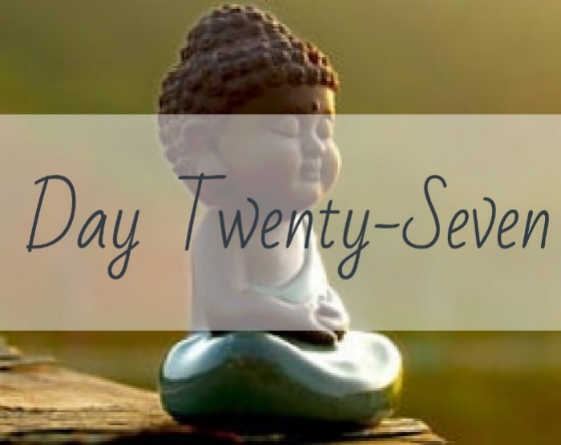

Think of a time when you were very critical of yourself. Maybe you did something you considered ‘stupid’ or said something ‘dumb’. What did you say to yourself that was critical? ___________________________________________________________________________________________________________________________________________________________________________________________________________________________________________________________________________________________________________________________________________________________________________________________________________________________________________________________________________________________________

In what ways did being critical help this situation?_____________________________ _________________________________________________________________________________________________________________________________________________________________________________________________________________________________________________________________________________________________________________________________________________________

How did you feel? ______________________________________________________ ___________________________________________________________________________________________________________________________________________________________________________________________________________________________________________________________________________________________________________________________________________________________________________________________________________________________________________________________________________________________________

**Meditation**

Using these questions, confront the self-criticism:

• What evidence is there that my thoughts are true? __________________________ _______________________________________________________________________________________________________________________________________________________________________________________________________________ _____________________________________________________________________

• What evidence is there that they are not true? _____________________________ __________________________________________________________________________________________________________________________________________ _____________________________________________________________________ _____________________________________________________________________

• Are there any other facts I’ve overlooked? _________________________________ _______________________________________________________________________________________________________________________________________________________________________________________________________________ _____________________________________________________________________

• What other explanations could there be? __________________________________ _______________________________________________________________________________________________________________________________________________________________________________________________________________ _____________________________________________________________________

• What good comes to think this way? _____________________________________ _______________________________________________________________________________________________________________________________________________________________________________________________________________

• What would you tell a friend? ___________________________________________ _______________________________________________________________________________________________________________________________________________________________________________________________________________ _____________________________________________________________________

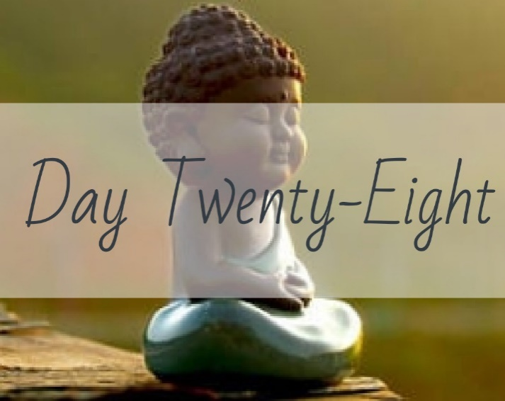

If you were in a relationship with yourself as if ‘Yourself’ was another human being, what would that look like? Where would you go with Yourself? What would you wear for Yourself? How would you do your hair? Would you laugh? Would you cry? Would you connect with all of the different sides of Yourself, even the ones you have tried to hide? Describe a relationship with Yourself as if there are two people: _____ ____________________________________________________________________________________________________________________________________________________________________________________________________________________________________________________________________________________________________________________________________________________________________________________________________________________________________________________________________________________________________________________________________________________________________________________________________________________________________________________________________________________________________________________________________________________________________________________________________________________________________________________________________________________________________________________________________________________________________________________________________________________________________________________________________________________________________________________________________________________________________________________________________________________________________________________________________________________________________________________________________________________________________________________________________________________________________

**Meditation**

When you were writing about being in a relationship with ‘Yourself’ what made you happy about the idea?___________________________________________________ _________________________________________________________________________________________________________________________________________________________________________________________________________________________________________________________________________________________________________________________________________________________

What made you uncomfortable, or felt weird? _______________________________ _________________________________________________________________________________________________________________________________________________________________________________________________________________________________________________________________________________________________________________________________________________________ _____________________________________________________________________

If you could cultivate a better relationship with ‘Yourself’, what kinds of things would you include? __________________________________________________________ ______________________________________________________________________________________________________________________________________________________________________________________________________________________________________________________________________________________________________________________________________________________________________________________________________________________________

If I was cultivating a relationship with myself I would remove criticism and add compassion. Because its You for You, what pieces of the relationship would you like to eliminate or replace? What would you replace with? ________________________ ______________________________________________________________________________________________________________________________________________________________________________________________________________________________________________________________________________________________________________________________________________________________________________________________________________________________

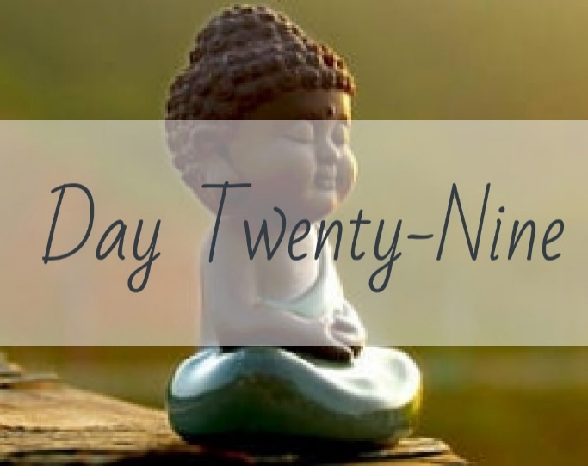

Inside ourselves we all have a little voice helping us along our path. Sometimes it opens doors for us and sometimes it is just there to ease the pain we feel when a door closes, especially if the door closes without warning or expectation. Often times the little voice is trying to give us hints on which way to go to free our souls. How is life calling you?_________________________________________________________ _________________________________________________________________________________________________________________________________________________________________________________________________________________________________________________________________________________________________________________________________________________________________________________________________________________________________________________________________________________________________________________________________________________________________________________________________________________________________________________________________________________________________________________________________________________________________________________________________________________________________________________________________________________________________________________________________________________________________________________________________________________________________________________________________________________________________________________________________________________________________________________________________________________________________________________________________________________________________________________________________________________________________________________________________________________________________________________________________________________________________________

**Meditation**

Using what you wrote above, spend time meditating on the following aspects:

You say that your life is calling you in certain ways: What keeps you from following? ___________________________________________________________________________________________________________________________________________________________________________________________________________________________________________________________________________________________________________________________________________________________________________________________________________________________________________________________________________________________________

What’s the worst that could happen if you followed? __________________________ ________________________________________________________________________________________________________________________________________________________________________________________________________________________________________________________________________________________________________________________________________________________________________________________________________________________________________________________________________________________________________________________________________________________________________

What are you losing out on when you do not follow? __________________________

____________________________________________________________________________________________________________________________________________________________________________________________________________________________________________________________________________________________________________________________________________________________________________________________________________________________________________________________________________________________________________________________________________________________________________________________________________________________________________________________________________________________________________________________________________________________________________________________________________________________________________________________

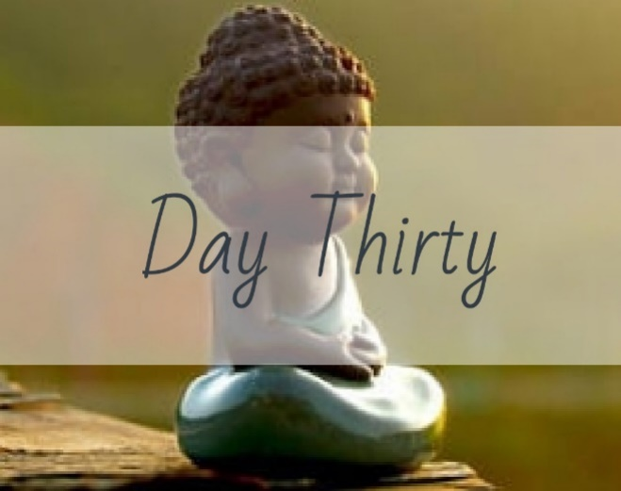

You have some very specific gifts. List them: _________________________________ ____________________________________________________________________________________________________________________________________________________________________________________________________________________________________________________________________________________

Why does the world need them? __________________________________________ ________________________________________________________________________________________________________________________________________________________________________________________________________________________________________________________________________________________________________________________________________________________________________________________________________________________________________________________________________________________________________________________________________________________________________

How can you affect the lives of others with your gifts? _________________________

__________________________________________________________________________________________________________________________________________________________________________________________________________________________________________________________________________________________________________________________________________________________________________________________________________________________________________________________________________________________________________________________________________________________________________________________________________________________________________________________________________________________________________________

**Meditation**

Your gifts and talents are unique to only you. Sure, someone else may be good at what you are good at, but what makes the gift just yours? What influences in your life have made your gifts unique? _________________________________________ ______________________________________________________________________________________________________________________________________________________________________________________________________________________________________________________________________________________________________________________________________________________________________________________________________________________________________________________________________________________________________________________________________________________________________________________________________________________________________________________________________________________________________________________________________________________________________________________________________________________________________________________________________________________________________________________________________________________________________________________________________________________________________________________________________________________________________________________________________________________________________________________________________________________________________________________________________________________________________________________________________________________________________________________________________________________________________________________________________________________________________________________________________________________________________________________________________________________________________________________________________________________________________________________________________________________________________________________________________________________________________________________________________________________________________________________________________________________________________________________________________________________________________________________________________________________________________________________________________________________

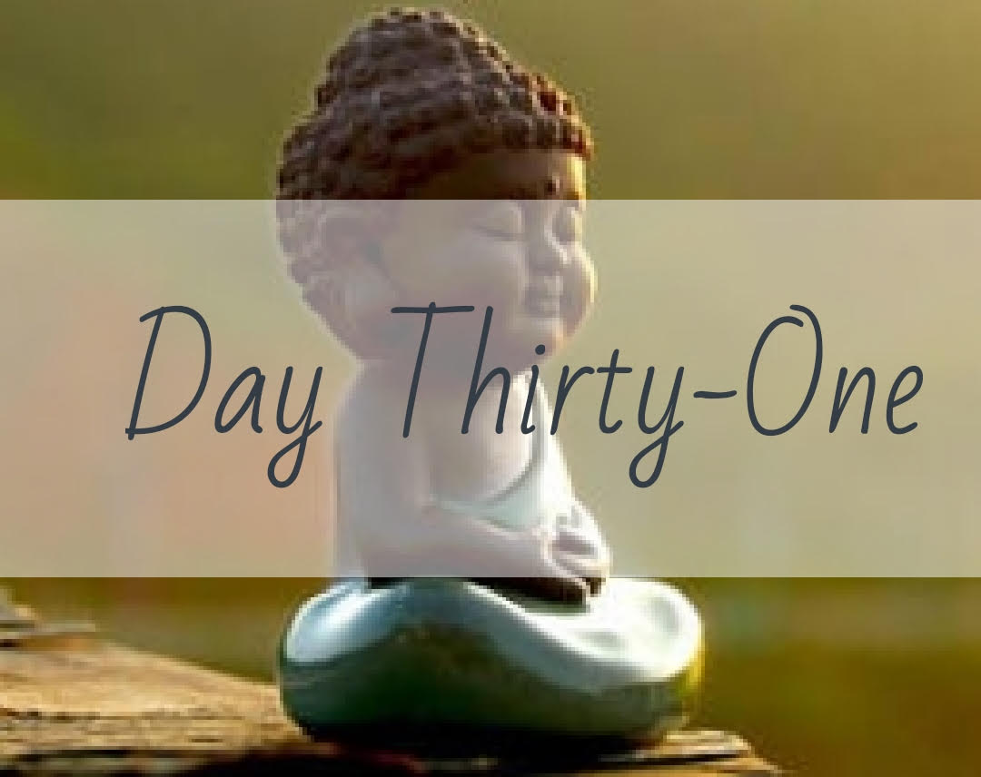

If you died tomorrow, what would you regret not doing, not being, or not having in your life? _____________________________________________________________ ________________________________________________________________________________________________________________________________________________________________________________________________________________________________________________________________________________________________________________________________________________________________________________________________________________________________________________________________________________________________________________________________________________________________________

Name 3 ways you can start TODAY bringing more of those desired topics into your life: __________________________________________________________________ _______________________________________________________________________________________________________________________________________________________________________________________________________________________________________________________________________________________________________________________________________________________________________________________________________________________________________________________________________________________________________________________________________________________________________________________________________________________________________________________________________________________________________________________________________________________________________________________

**Meditation**

Brightest Blessings! You made it through the whole 31 days of Mindfulness Journaling!! I am proud of you and I hope that YOU are proud of yourself. You probably don’t know it but you have done something so powerful for your self-discovery journey. I encourage you to continue practicing Mindfulness in some form every day!! Over time it really does bring peace into your life and connects you with purpose and self.

Take some time now to meditate on your journey. Final assignment - Name 3 things you learned about yourself over this past month: _____________________________ _______________________________________________________________________________________________________________________________________________________________________________________________________________________________________________________________________________________________________________________________________________________________________________________________________________________________________________________________________________________________________________________________________________________________________________________________________________________________________________________________________________________________________________________________________________________________________________________________________________________________________________________________________________________________________________________________________________________________________________________________________________________________________________________________________________________________________________________________________________________________________________________________________________________________________________________________________________________________________________________________________________________________________________________________________________________________________________________________________________________________________________________________________________________________________________________________________________________________________________________________________________________________________________________

Appendix

## **Mindfulness techniques**

There is more than one way to practice mindfulness, but the goal of any mindfulness technique is to achieve a state of alert, focused relaxation by deliberately paying attention to thoughts and sensations without judgment. This allows the mind to refocus on the present moment. All mindfulness techniques are a form of meditation.

**Basic mindfulness meditation** – Sit quietly and focus on your natural breathing or on a word or “mantra” that you repeat silently. Allow thoughts to come and go without judgment and return to your focus on breath or mantra.

**Body sensations** – Notice subtle body sensations such as an itch or tingling without judgment and let them pass. Notice each part of your body in succession from head to toe.

**Sensory** – Notice sights, sounds, smells, tastes, and touches. Name them “sight,” “sound,” “smell,” “taste,” or “touch” without judgment and let them go.

**Emotions** – Allow emotions to be present without judgment. Practice a steady and relaxed naming of emotions: “joy,” “anger,” “frustration.” Accept the presence of the emotions without judgment and let them go.

**Urge surfing** – Cope with cravings (for addictive substances or behaviors) and allow them to pass. Notice how your body feels as the craving enters. Replace the wish for the craving to go away with the certain knowledge that it will subside.

**Mindfulness meditation and other practices**

Mindfulness can be cultivated through mindfulness meditation, a systematic method of focusing your attention. You can learn to meditate on your own, following instructions in books or on tape. However, you may benefit from the support of an instructor or group to answer questions and help you stay motivated. Look for someone using meditation in a way compatible with your beliefs and goals.

If you have a medical condition, you may prefer a medically oriented program that incorporates meditation. Ask your physician or hospital about local groups. Insurance companies increasingly cover the cost of meditation instruction.

**Getting started on your own**

Some types of meditation primarily involve concentration—repeating a phrase or focusing on the sensation of breathing, allowing the parade of thoughts that inevitably arise to come and go. Concentration meditation techniques, as well as other activities such as tai chi or yoga, can induce the well-known relaxation response, which is very valuable in reducing the body’s response to stress.

Mindfulness meditation builds upon concentration practices. Here’s how it works:

**Go with the flow.** In mindfulness meditation, once you establish concentration, you observe the flow of inner thoughts, emotions, and bodily sensations without judging them as good or bad.

**Pay attention.** You also notice external sensations such as sounds, sights, and touch that make up your moment-to-moment experience. The challenge is not to latch onto a particular idea, emotion, or sensation, or to get caught in thinking about the past or the future. Instead, you watch what comes and goes in your mind and discover which mental habits produce a feeling of well-being or suffering.

**Stay with it.** At times, this process may not seem relaxing at all, but over time it provides a key to greater happiness and self-awareness as you become comfortable with a wider and wider range of your experiences.

**Practice acceptance**

Above all, mindfulness practice involves accepting whatever arises in your awareness at each moment. It involves being kind and forgiving toward yourself.

Some tips to keep in mind:

**Gently redirect.** If your mind wanders into planning, daydreaming, or criticism, notice where it has gone and gently redirect it to sensations in the present.

**Try and try again.** If you miss your intended meditation session, simply start again.

By practicing accepting your experience during meditation, it becomes easier to accept whatever comes your way during the rest of your day.

Cultivate mindfulness informally

In addition to formal meditation, you can also cultivate mindfulness informally by focusing your attention on your moment-to-moment sensations during everyday activities. This is done by single-tasking—doing one thing at a time and giving it your full attention. As you floss your teeth, pet the dog, or eat an apple, slow down the process and be fully present as it unfolds and involves all of your senses.

**Mindfulness exercises**

If mindfulness meditation appeals to you, going to a class or listening to a meditation tape can be a good way to start. In the meantime, here are two mindfulness exercises you can try on your own.

**Basic mindfulness meditation**

This exercise teaches basic mindfulness meditation.

* Sit on a straight-backed chair or cross-legged on the floor.
* Focus on an aspect of your breathing, such as the sensations of air flowing into your nostrils and out of your mouth, or your belly rising and falling as you inhale and exhale.
* Once you’ve narrowed your concentration in this way, begin to widen your focus. Become aware of sounds, sensations, and your ideas.
* Embrace and consider each thought or sensation without judging it good or bad. If your mind starts to race, return your focus to your breathing. Then expand your awareness again.

**Learning to stay in the present**

A less formal approach to mindfulness can also help you to stay in the present and fully participate in your life. You can choose any task or moment to practice informal mindfulness, whether you are eating, showering, walking, touching a partner, or playing with a child or grandchild. Attending to these points will help:

* Start by bringing your attention to the sensations in your body
* Breathe in through your nose, allowing the air downward into your lower belly. Let your abdomen expand fully.
* Now breathe out through your mouth
* Notice the sensations of each inhalation and exhalation
* Proceed with the task at hand slowly and with full deliberation
* Engage your senses fully. Notice each sight, touch, and sound so that you savor every sensation.
* When you notice that your mind has wandered from the task at hand, gently bring your attention back to the sensations of the moment.

Riding the Wave Skill

*This skill can be used with **any** emotion you are having trouble managing.

You are thinking thoughts that are contributing to feelings of unhappiness:

1. Take a few minutes to notice how your body feels at this moment. Identify where it seems like you are feeling the unhappiness the strongest.
2. Hold the thought of where you feel the unhappiness the strongest, explore the sensations of the unhappiness: Is it like pressure? Is it heavy or light? Dark or light? Does it tingle? etc. Are there any colors in your mind as you explore the unhappiness? Try to draw a mental circle around the feelings.
3. Bring your attention to your breath. You don’t have to change it, just make sure you are doing it! Notice your breath for a minute or two.
4. Go back to the sensations of unhappiness. Notice the sensations that come up and if the visualization is too intense, refocus on your breath again. This is the crux of riding the wave. The feelings *will* become less and less intense as you continue to go back and forth between your thoughts and your breath.
5. Visualize the sensations of unhappiness and silently describe the sensations in a non-judgmental way (look at the non-judgmental stance worksheet again if you need to).
6. Visualize the sensations dissipating from your body with your breath.
7. Repeat until you can no longer feel them.
8. Thank yourself for being kind and compassionate with yourself